CPUE Standardization by GLM

(Menu-driven software) (1st version)

Manual

April, 2016

Developer: Dr. Kiyoshi ITOH

Environmental Simulation Laboratory (ELS)

2F, Noble Building, 2 -4 –1, Arajuku,

Kawagoe-City, Saitama, Japan 350-1124

Phone: 81(Japan)-49-242-9262, FAX: 81(Japan)-49-241-2442

E-mail: [Itoh@esl.co.jp](mailto:Itoh@esl.co.jp) URL: http://www.esl.co.jp

Technical support: Dr Tom Nishida  
Resources Person

SEAFDEC Neritic tuna Stock Assessment Project

National Research Institute of Far Seas Fisheries (NRIFSF)

Japan Fisheries and Education Agency   
5-7-1, Orido, Shimizu-Ward, Shizuoka-City, Shizuoka, Japan 424-8633  
E-mail: aco20320@par.odn.ne.jp Phone/FAX (direct):81(Japan)-54-336-5834

URL: <http://fsf.fra.affrc.go.jp/>

**Specification**

This software was developed using “R computer language” to perform　nominal CPUE (Catch-Per-Unit-of-Effort) standardization by GLM (Generalized Linear Model) from fisheries data. Nominal CPUE means Catch/Fishing effort, where catch and fishing effort data area the original (raw) data. GLM is a flexible generalization of ordinary [linear regression](https://en.wikipedia.org/wiki/Linear_regression) that allows for response variables that have error distribution models other than a [normal distribution](https://en.wikipedia.org/wiki/Normal_distribution).

This software can conduct “GLM” and create relevant outputs using menus without making any programming. Main input (covariates) are “Year” effect, “season” effect, “area” effect. As for outputs, standard GLM outputs created by “R language” will be automatically produced for each GLM run. Major outputs are (a) ANOVA table, (b) Coefficients of estimated parameters, (c) Estimated annual standardized CPUE, (d) residual plots and (e) Q-Q plots.

1. **Install**

Down load the software from <http://ocean-info.ddo.jp/kobeaspm/glm/cpueglm_setup.exe>

It will take about 5 minutes depending on performance to download the setup program (cpueglm_setup.exe) (49.9 MB) shown as below, then double click.

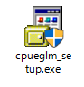

Then follow steps as below:

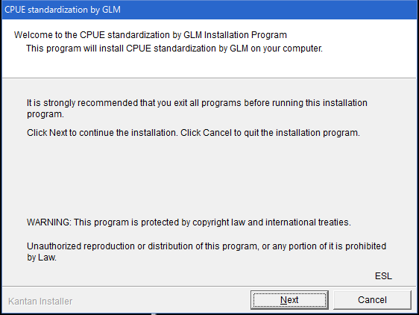

Click “Next”

Install folder

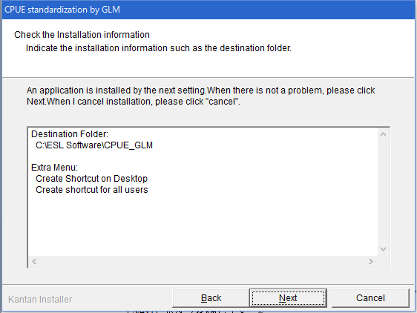

Click “Next”

Confirm the folder for installment

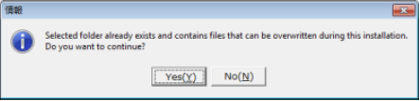

Completion of the installment

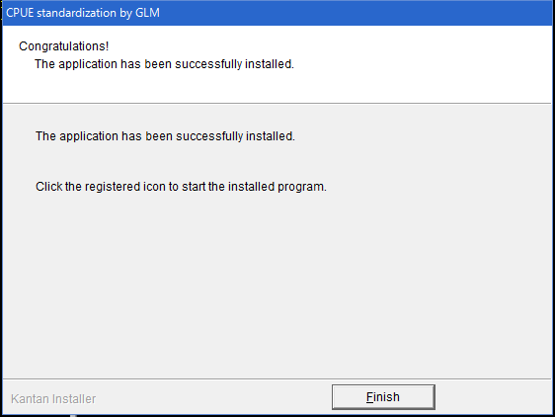

Click “Finish”

Install Microsoft .Net Framework 4

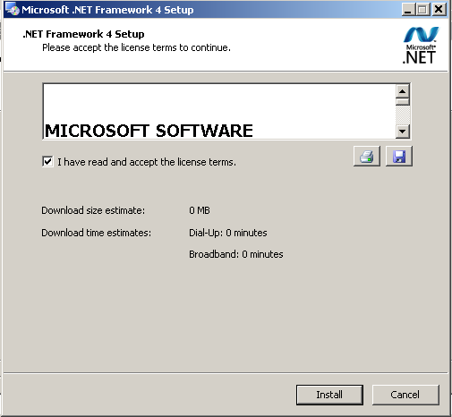

Check “I have read and accept the license terms” and click “Install”.

Completion of installment of Microsoft .Net Framework 4

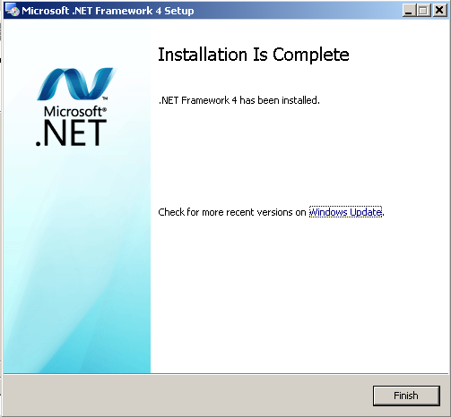

Click “Finish”

Make sure the icon “CPUE standardization by GLM” in the desktop



1. **Starting the software**
2. Double click “CPUE standardization by GLM”



If the R program is not found, you will see the message (next page) then install “R” program and re-start.

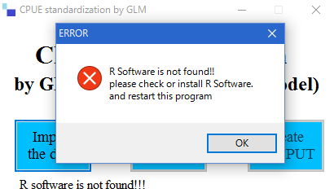

1. Locate R path by clicking the button

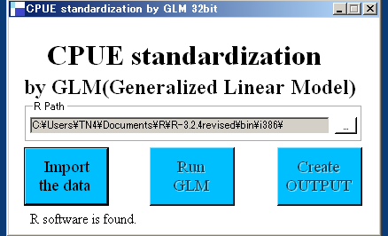

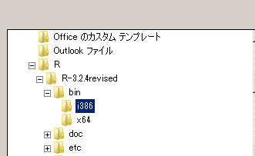

1. Import the data.

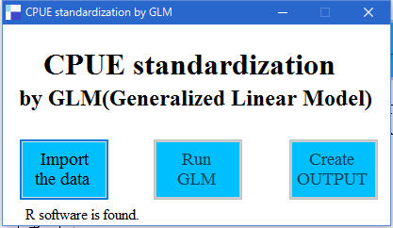

Click “Import the data”.

1. Select the nominal CPUE data set

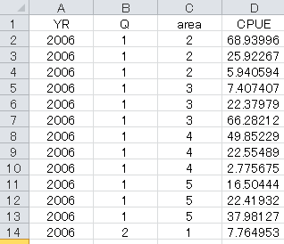

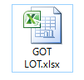

Select Excel file (.xlsx) like the above file (example).

Note: To create the nominal CPUE data set. As shown above,

create the data set by the excel book file (.xlsx) including:

A year,

B season (month or quarter),

C area

D nominal CPUE

1. Run GLM by R

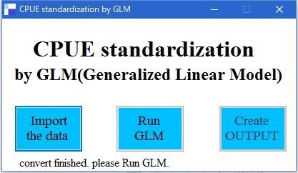

Click “RUN GLM”, proceed running GLM

1. Create output

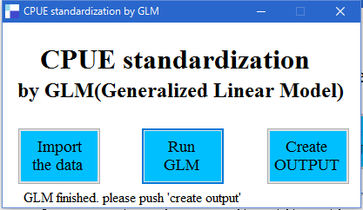

Click “Create OUTPUT”, create reports.

1. Report (OUTPUT) files

In the same folder of the input data, you will get two output files as below:

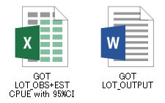

**Excel book file (GOT LOT_OBS+EST CPUE with 95% CI.xlsx) includes flowing annual figures:**

A: OBS (nominal) CPUE

B: EST (standardized) CPUE and its 95% CI (Confident Interval).

C: Lower limit of 95% CI.

D: Upper limit of 95% CI.

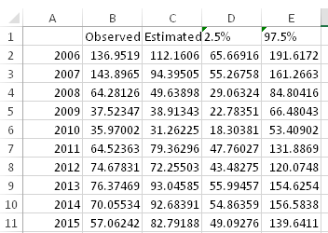

If you process this sheet, you will see the whole picture as shown next page. The graph of these 4 variable are provided in the output as shown in page 11.



**Word file (GOT LOT_OUTPUT.docx) includes flowing 4 reports:**

[1]　ANOVA table



[2] Graph including 4 annual figures

OBS (nominal) CPUE Dot

EST (standardized) CPUE Solid line

C: Lower limit of 95% CI Dot line (Lower)

D: Upper limit of 95% CI. Dot line (upper)



**[2] Histogram of residuals**



**[3]　QQ plot**

